Alabama Sasquatch Jiu-Jitsu

Welcome to Alabama Sasquatch Jiu-Jitsu. This document will serve to help orient you to the way we do things here. In many ways our school is similar to most traditional martial arts schools, but jiu-jitsu has a few unique qualities that it would be helpful for you to be acquainted with as you begin your jiu-jitsu journey.

Academy History
Alabama Sasquatch is the home gym and jiu-jitsu studio created by Dave Hall. Prior to the COVID-19 pandemic of 2020 Dave owned Agoge Fitness Systems in Lakeview where he taught strength training and martial arts. Dave has been a student of the martial arts his entire adult life. Over the last 30 years he has spent extensive time studying various arts including, Tai Chi Chuan (Yang and Chen styles), Shorin Ryu karate, 8 Step Preying Mantis, Muay Thai Boxing, Kali Arnis, and Brazilian Jiu-Jitsu. Currently a blue belt in jiu-jitsu, Dave has been teaching for three years and is a student of Professor George Wehby at Lionheart Jiu-Jitsu. Dave teaches both adult and children’s classes

School Lineage
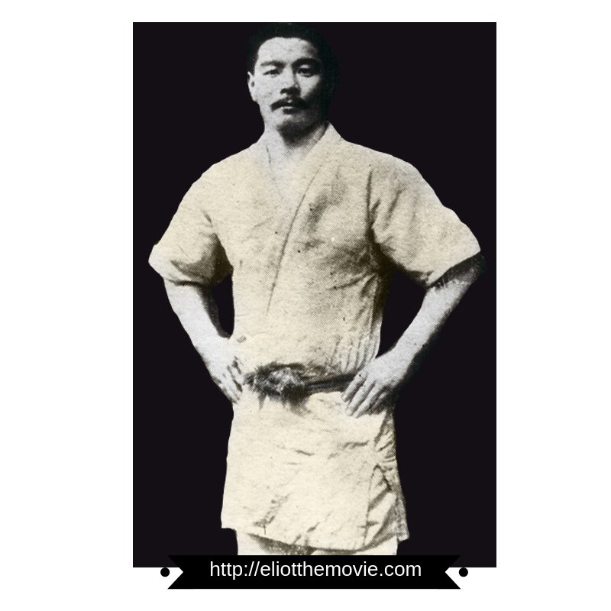
Mitsuyo Maeda
Sensei Mitsuyo Maeda was a Japanese judōka and prizefighter who emigrated to Brazil in the early 1900s. He pioneered Judo in Brazil and was fundamental to the development of Brazilian Jiu-jitsu. He is often referred to as the Father of Brazilian Jiu-Jitsu.

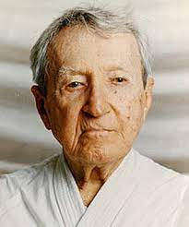
Carlos Gracie
Professor Carlos Gracie is the older brother of the somewhat more famous Helio Gracie. Carlos studied judo under Mitsuyo Maeda and with Helio and other members of his family is credited with the creation of Gracie Jiu-jitsu, known worldwide as Brazilian Jiu-jitsu.

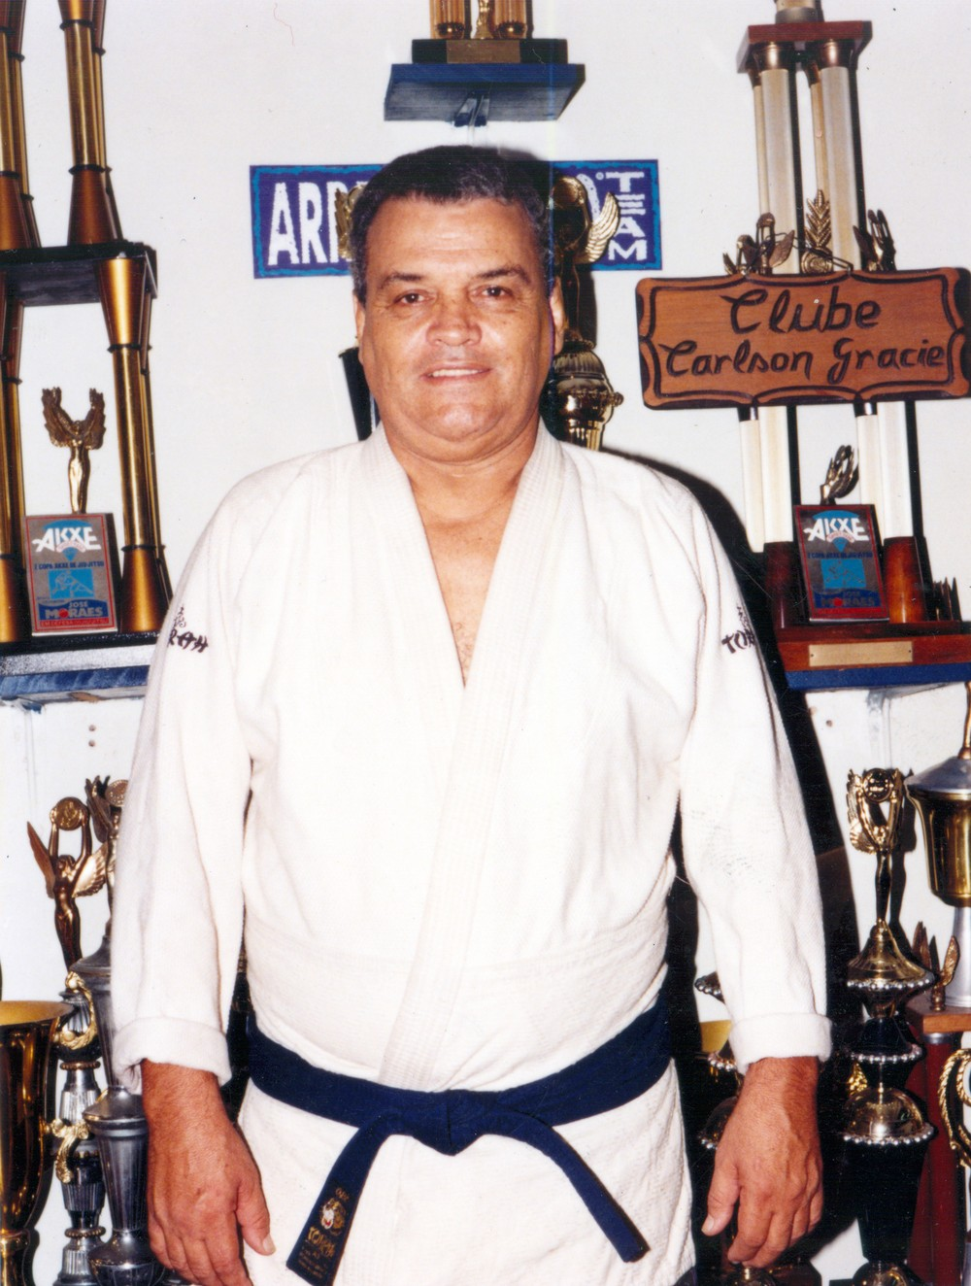
Carlson Gracie
Professor Carlson Gracie is the son of Carlos Gracie. He is considered to be one of the most influential figures of the sport and is highly regarded both as a competitor and a coach.

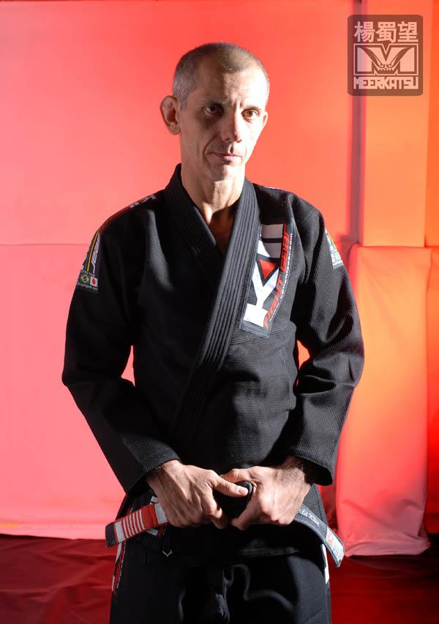
Ricardo De La Riva
Professor Ricardo De La Riva is known as one of the most creative players in BJJ. He is best known as the creator of the De La Riva guard, a fundamental guard taught in most jiu-jitsu schools and now considered an essential part of the BJJ canon.

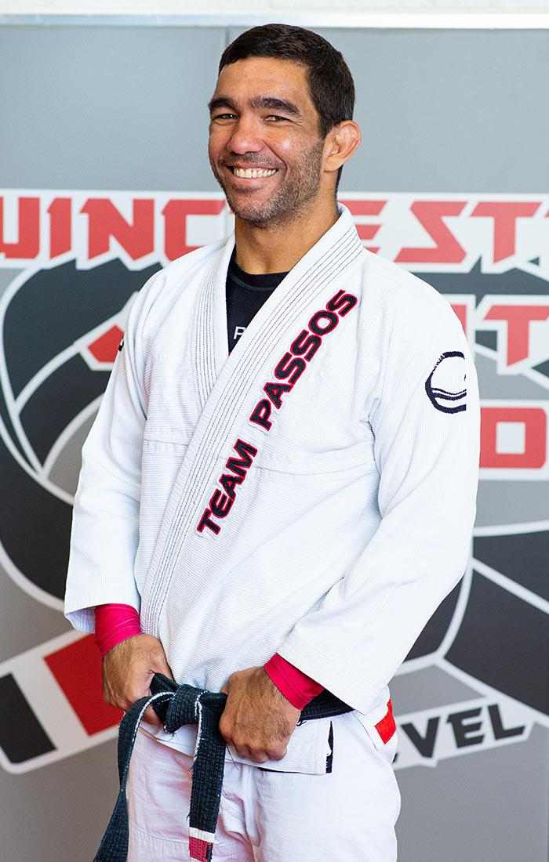
Antonio “Tony” Passos
Professor Tony Passos is one of the few Brazilian Jiu Jitsu black belts under Ricardo de la Riva. He is currently an IBJJF certified third degree black belt and a proud member and coach of Team Atos Jiu Jitsu. Professor Tony started training Jiu-Jitsu at 18 years old in Recife, Brazil and began teaching in 2002. He has trained with and learned from world champions such as Andre Galvao, Guto Campos, Claudio Calasans and many others.


George Wehby
Professor George Wehby earned his black belt in April, 2011. He has served as a United States Marine, including service in the Yankee White/White House NCO program, a Police Officer, an EMT, a Federal Air Marshall, and a subject matter expert for Personal Defense TV. In 2006 he opened his first martial arts school, the MMA Institute of Winchester in Winchester, Virginia. In late 2014 he sold his school and moved to Birmingham where he became a head instructor at Spartan Fitness. In January of 2016 he opened Lionheart Jiu-Jitsu Academy. Over the course of his career, Professor Wehby has helped countless individuals learn and benefit from jiu-jitsu and the martial arts.

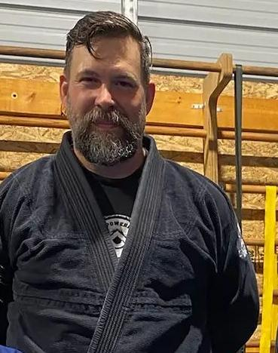
Dave Hall
Coach Dave Hall is currently a blue belt studying under Professor George Wehby at Lionheart Jiu-Jitsu Academy. He has been teaching beginner adult and children’s classes for three years.

Class Times

Kid’s Class
Tuesday 5 PM
Thursday 5 PM

Adult’s Class
Tuesday 6 PM
Thursday 6 PM

Class Flow
Every class has a standard format. Having knowledge of that format prior to class allows for a more even flow and greater comfort on your part.

1. Line up and bow in
This is the formal beginning of class. All students line up on the blue matted wall opposite the stall bars from more advanced belts on door end descending to white belts towards the strength side of the gym
2. Warm up
Jiu-jitsu is a physically demanding art. It is important to be fully warmed up and ready to go prior to the main body of the class. Warmups not only help prep the body for the work to come but also decrease the likelihood of injury. Expect a combination of calisthenics and applicable BJJ movements.
3. Concept of the day
Coach Dave will break down a designated concept or movement. Skills are usually taught in week-long chunks. This is your time to listen and observe. Be sure to position yourself on the mat so that you can see. Feel free to move to a different vantage point as needed in order to observe more closely.
4. Drilling
After the concept or movement of the day is demonstrated, partner up with another teammate and practice the movement using your teammate as a live “dummy.” This is your time to apply and feel the movement. This is not time to talk or practice other techniques. If you have a question or get stuck feel free to get the Coach’s attention and ask questions.
5. Sparring
This is an active, full speed sparring session. Our intention during this time is to apply the techniques that have been taught. Bear in mind, that while it is full speed, this is not a street fight, and we are not trying to harm our training partners. Your training partner is your greatest asset in jiu-jitsu. Without good training partners you will never progress in this art. Train hard, but be respectful at all times.
6. Ending class
Line up on the wall, just as you did at the beginning of class, and bow out. After the bow face the door and proceed down the line, bumping fists first with the Coach then each succeeding student before and then after you in rank. This is a way of showing respect for your training partners and acknowledging how essential they are to your training.

What do I wear?
Gi
The standard uniform for Brazilian Jiu-Jitsu is referred to as a “gi”. You will be given your first gi when you join the academy. We recommend you buy another one or two to rotate through during the week. Gis can be washed in your regular washing machine, although it is generally recommended that you let them air dry to prevent shrinkage. Having an extra gi or two makes it easier to always have a clean spare on hand.

While shopping for gis you’ll see they come in all kinds of colors. Acceptable colors within our academy are blue, black, or white.

During class you’ll often hear references to different parts of the gi. These are:

Skirt - this is the lower hem of the gi jacket, also known as a kimono. The skirt of your kimono should reach the tops of your thighs.
Lapel - refers to the collar of the gi. When wearing your gi cross the left lapel over the right.
Sleeves - the part of the kimono that covers your arms. Properly fitted sleeves should be no more than 5 cm away from your wrists when your arms are held parallel to the ground.
Pants Cuff - this is the bottom of your pants leg. Proper fit is for the pants leg to end no more than 5 cm above your ankle bone.

These reference areas on your gi are especially relevant when establishing grips (i.e. how you grab your opponent during drilling or sparring.) Special Note: DO NOT allow your fingers inside your opponents sleeves or pants cuffs. Make sure that your grips are outside the fabric in these areas. Fingers inside a sleeve of pants cuff can easily get caught in the fabric which can lead to broken fingers and precious time lost training. It is generally safe, acceptable, and often tactically appropriate to place your fingers inside your own sleeve or cuff.

Under the Gi
All students are required to wear a rash guard under their gi. A rash guard is a tight fitting shirt of spandex or other stretchy material designed to prevent mat burn, pulled body hair, and other inconveniences of sparring. Rash guards may be either long or short sleeved. Do not wear t-shirts or other loose fitting undergarments as they will likely get stretched and/or torn.

Wear form fitting underwear, both for your comfort (and ours) and protection. It is recommended that women wear a sports bra under their rash guard.

Belt
Your belt does more than just serve to keep your gi closed. Belts are used as a designation of rank. When you join the academy you will be issued a white belt designating you as a beginner. You may think of each belt rank as a level of schooling.

White (Elementary School)
Blue (High School)
Purple (Bachelor’s degree)
Brown (Master’s degree)
Black (Doctorate)

Within a belt rank are sub ranks designated by stripes. You may attain four stripes at each level before being promoted to the next belt. There are a few methods for tying the belt but they all center around a basic square knot.

Children have a separate ranking system. Jiu-jitsu is known for having a tough promotional system, belts are earned not awarded simply because you’ve paid tuition for a certain amount of time. As such, we also recognize the need for greater recognition of children’s accomplishments. The children’s belt ranking system addresses this. Students under the age of 16 adhere to the kid’s promotion schedule. Stripes are awarded based on attendance, participation, and good behavior.
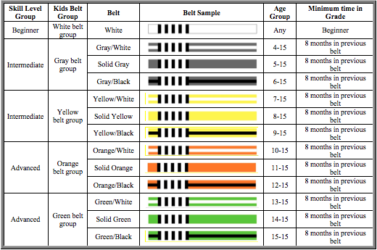
At 16 a child is eligible for the adult class. Having completed the green belt group a child may also be eligible for promotion to blue belt.

Hygiene
Never under any circumstance come into the academy if you are sick or feel like you are getting sick. Be mindful of your classmates and yourself. Training while sick can lead to injury or prolonged illness that ultimately can delay your training. Spreading disease within the academy limits not only available training partners but hurts the school as a whole. It’s better to miss a day, just in case, than to risk infecting you classmates or the Coach.

Trim your finger and toenails. Scratches can easily occur during a roll. Keeping your nails short minimizes this likelihood. Blood on the mats, especially minor traces of blood easily missed, becomes a breeding ground for MRSA and other nasty bacteria leading to infections, rashes, and other skin issues.

Remove all jewelry. Like long nails, jewelry can easily scratch or get caught and cause an injury. If you have long hair, be sure to tie it back.

Wash your Gi after every class. JIu-jitsu is by its nature very up close and personal. No one wants to roll with a damp, stinky gi that hasn’t been washed in a week. OdoBan is a great product you can add to your washing machine to kill odors. It comes in a concentrate, ⅛ of a cup is enough to keep a full load stink free.

We strive to keep our mats clean, but jiu-jitsu is a hot and sweaty business - the perfect breeding ground for all kinds of bacteria. Do yourself a favor and wash after class. Additionally, if you’ve already had a hot sweaty day, go ahead and shower before class. We’ll all like you more for it.

If you have a rash or something that looks funny on your body, have it checked out before you come back. We are diligent about cleaning and disinfecting the mats. However, skin ailments like MRSA and ringworm are easily spread. If you notice anything like that get it cleared up before returning to training. You are always welcome (and recommended) to come and observe if you can’t train unless you have a fever and then, obviously, stay home.

No shoes on the mats. Ever. Your shoes track in dirt and germs from outside then transfer that dirt to the mats. You’re not going to rub the bottom of your shoe on your face are you?

No food or drink on the mats. This is how you get ants. You don’t want ants do you?

Etiquette 101
A black belt instructor is referred to as “Professor.” This is a sign of respect for both the art and his/her accomplishments. All other instructors are referred to as “Coach.”

While Drilling

Don’t try to instruct unless you are an advanced belt. If you have a question on the technique, ask the Professor or Coach.

Be a good training partner. Don’t be a limp noodle. Offer enough resistance so that your partner can apply the technique properly and don’t flop over when the technique is applied. Conversely, don’t offer so much resistance that your partner cannot effectively train the technique. This is not a fight, nor is it sparring. This is a chance to learn the movement and build muscle memory.

Jiu-jitsu movements are complex and have a lot of moving parts. Your hands are doing one thing while your legs and feet are doing another, often all four limbs are each doing their own thing while you're also using your core. It can be a lot at first. When learning new techniques, think in terms of concepts. Where am I and where am I trying to go? By focusing on the beginning and the end you can simplify a technique. As you practice you can begin to fill in the middle a chunk at a time.

Jiu-jitsu is taught via immersion. Progress is not linear and everyone’s path is different. Higher belts will and should drill with lower belts. If you are a lower belt don’t be afraid to ask a higher belt to drill it will enhance your learning.

White belts should avoid drilling with resistance, i.e. attempting to mimic the conditions of a roll. The first step of learning any technique is muscle memory. Adding resistance adds to many additional variables and complicates the learning. Remember, practice not until you can get it right, but until you can’t get it wrong.

While rolling

Rolling is sparring. It’s a chance to apply the techniques you’ve learned under live conditions. Do your best to apply the technique of the day. Don’t be afraid to “tap.” Tapping indicates to your partner that they’ve caught you in an untenable position you can’t get out of. Over the course of your training you will attempt many things. Some will work, most will not. Don’t be afraid to fail. You’re not “losing” you are learning.

You will be paired with a partner around your size if one is available. If you are asked to choose a partner and don’t know their name make a choice on whom you want to roll with, point at them and ask their name after.

If you are paired with a smaller partner don’t be a jerk. This is a nuanced situation but one you can and will learn to navigate. Roll with intent but don’t obliterate your partner just because you can. Use this time to work on techniques you might not be as familiar with or you might consider “riskier” in the sense that they might fail. You may want to reconsider this last suggestion if the smaller person you are rolling with is a higher belt. This is the joy of jiu-jitsu.

If you are a guy and paired with a girl don’t be a jerk. Apply the same rules you would with a smaller partner. If you are weird about rolling with a woman, get over it. She’s going to try and choke you out. Take the roll seriously.

No small joint manipulations, punching, kicking, or gouging. The whole reason we can train as intensely as we do is because certain rules are in effect for safety. This is not the UFC. You are not the Ultimate Warrior.

FAQ
How many times do I need to train per week?

It is recommended that you find at least two days a week to train in order to progress. More is obviously better but depends on your schedule, conditioning, and recovery. If you find yourself beat up and sore all the time and prone to injury it may be best to take a step back and allow yourself more time to recover between classes or to opt of rolling every single time.

Do I have to roll?

If you want to get better you do. But that doesn’t mean you have to roll every time. At your first class you simply observe the rolls. That way you can get an idea for what rolling is and see that while it may look intense it is not a fight and actually quite fun. Once you do start rolling you can always opt out by sitting on the opposite wall. Good reasons for sitting out are:
- You’re tired. It takes a while to build sufficient conditioning to roll every time. If your last roll wiped you out and you need a break. Sit out a roll to recover.
- You’re injured. You’ve got a nagging injury, not bad enough to keep you from drilling but enough that it’s not wise to roll. Good for you for coming to class and doing what you can.

Should I watch YouTube videos/tutorials?

No. Your coach has a plan. It’s their job to present you with the tools you need to be the best jiu-jitsu player you can be. YouTube can be a distraction. Not all techniques are created equal and there are plenty of moves and strategies we don’t use for a number of reasons. You trust your Coach enough to pay for tuition. Trust him to guide your path.

When will I get promoted?

There is so much to learn in jiu-jitsu you should worry more about learning the techniques and doing your best in your rolls. Promotions will take care of themselves.

Can I compete?

It’s good that you want to compete but not good if you try before you’re ready. Have a conversation with your coach before enrolling and see if it’s right for you.

